George Watson drowns saving others

8th March 1943: African-American soldier dies saving shipwreck survivors off New Guinea - and is much later awarded the Medal of Honor
MAR 8

SAVE |  | ▷ LISTEN

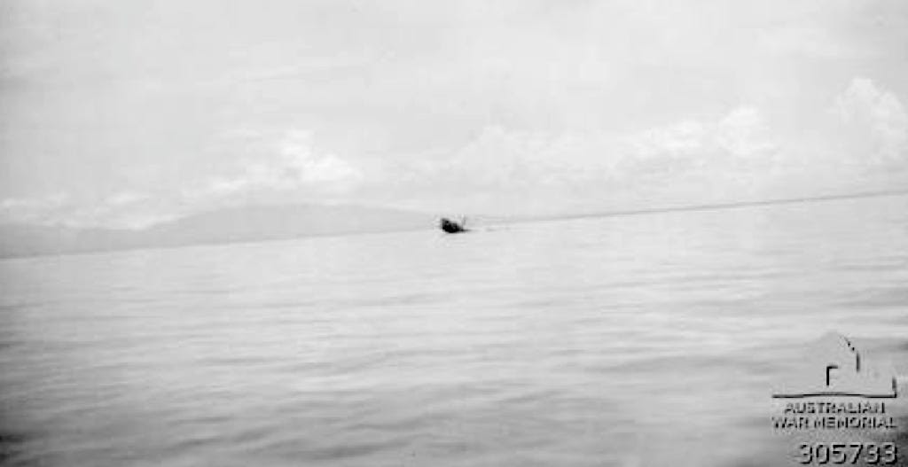
The US supply ship - the former Dutch East Indies freighter - ‘s Jacob sinking on the 8th March 1943, seen from the approaching HMAS Bendigo. The exhausted George Watson was sucked down as the ship sank.
While the Allies had delivered a devastating blow to the Japanese in their attempt to reinforce New Guinea in the battle of the Bismarck Sea, their own efforts to resupply the island were not immune from air attack.
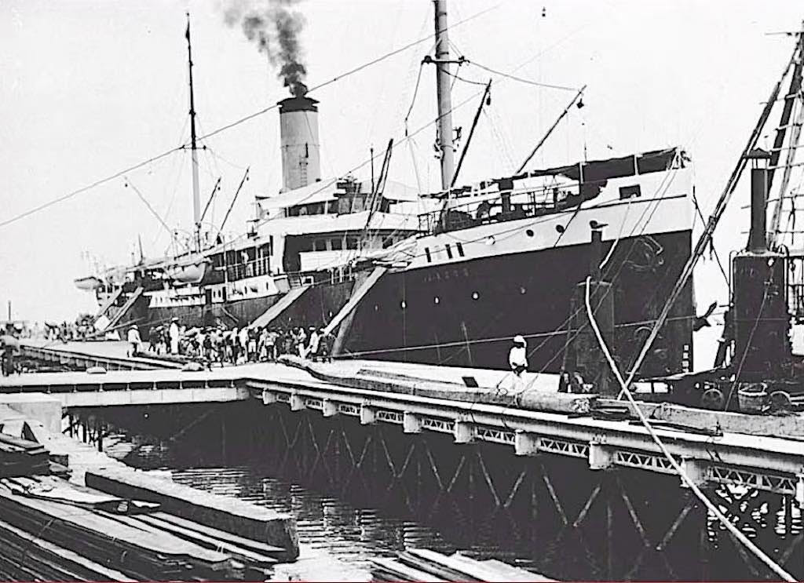
The Dutch East Indies freighter the ‘s Jacob, seen in 1907, operated in what is today the Indonesian archipelago. She was attacked and sunk by Japanese aircraft on 8th March 1943, five men died including Private George Watson.
On 8th March the former Dutch East Indies freighter the ‘s Jacob, which had been taken over by the US as a troop and supply ship, was hit by three bombs from high-flying Japanese aircraft as it approached New Guinea. An uncontrollable fire broke out - and the order was given to abandon ship. Amongst the men who went over the side were many who could not swim.
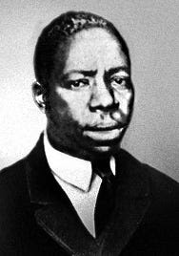
George Watson (1914-1943) was the first African American to receive the Distinguished Service Cross.
Private George Watson went to their rescue but exhausted himself doing so. He drowned as the ‘s Jacob sank.
Watson was originally awarded the Army's second-highest decoration, the Distinguished Service Cross, becoming the first African American to receive the award. The award was upgraded to the Medal of Honor in 1997 following a 1990s review of the procedures followed in awarding honours to African Americans during the war.
Private Watson, instead of seeking to save himself, remained in deep waters long enough to assist several soldiers who could not swim to reach the safety of a life raft. This heroic action, which subsequently cost him his life, resulted in saving the lives of several of his comrades.
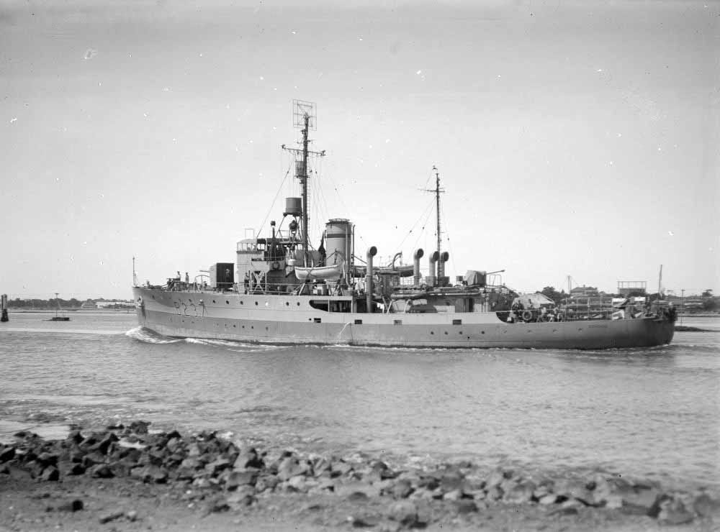
The Australian corvette HMAS Bendigo went to the rescue
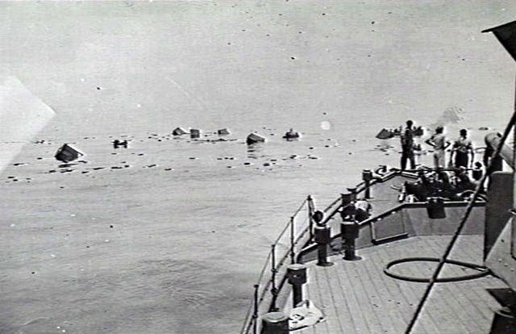
The Bendigo arrived just too late. The view from HMAS Bendigo as she arrived on the scene, with survivors clinging to wreckage in the water.
The full citation reads:
GEORGE WATSON
MARCH 8, 1943
NEAR PORLOCK HARBOR, NEW GUINEA
For conspicuous gallantry and intrepidity at the risk of his life above and beyond the call of duty: Private George Watson distinguished himself by extraordinary heroism on 8 March 1943, while serving in the Pacific Command with the 2d Battalion, 29th Quartermaster Regiment, near Porlock Harbor, New Guinea.
Private Watson was onboard a troop ship, the Dutch Steamer (United States Army Transport) Jacob, when it was attacked and hit by enemy bombers. Before it sank, the ship was abandoned. Private Watson, instead of seeking to save himself, remained in deep waters long enough to assist several soldiers who could not swim to reach the safety of a life raft. This heroic action, which subsequently cost him his life, resulted in saving the lives of several of his comrades.
Weakened by continuous physical exertion and overcome by muscular fatigue, Private Watson drowned when the suction of the sinking ship dragged him beneath the surface of the swirling waters.
His demonstrated bravery and unselfish act set in motion a train of compelling events that finally led to American victory in the Pacific. Private Watson's extraordinary valorous actions, his daring and inspiring leadership, and his self-sacrificing devotion to his fellow man exemplify the finest traditions of military service.

